User Guide:

Salesforce Tenancy Review

Version History

|  |  |  |  |
| --- | --- | --- | --- |
| **Version** | **Description of Change** | **Author** | **Date** |
| 1.0 | First Version | Nikki Papenfus | 08/09/2025 |

Table of Contents

1. Overview 3

2. Creating a Tenancy Review Opportunity 4

3. Rent Approval 5

4. Growth on Rent 8

5. Estate Performance Dashboard 10

6. Reviews in Progress 11

7. Tenancy Review Opportunity Details 13

7.1 Right-to-Rent Information 17

7.2 Set Licence Prices 18

7.3 Offer Details 19

8. Send an Offer 21

8.1 Reminder SMS & Emails 22

9. Offer Responses 23

10. Responding to Counteroffers & Asset Manager Approval 25

10.1 Suggested Price Above AM Minimum 26

10.2 Suggested Price Below AM Minimum 26

10.3 Asset Manager Approval 27

11. Renewal Feedback 30

12. Sending Documents 31

12.1 Section 13 for Post 33

12.2 RHW12 34

13. Defer Tenancy Review 35

14. Block Pricing Notes 36

15. Reports 37

15.1 Tenancy Review Dashboard 37

15.2 Formal Challenges 38

# Overview

Tenancy reviews are typically conducted when a fixed-term lease comes up for renewal, or annually for periodic tenancies. Rent will be increased on tenancy review.

The tenancy review process will be monitored according the following timeline:

|  |  |
| --- | --- |
| **Timeline Relative to the *Tenancy Review Date*** | |
| Tenancy review opportunity is automatically created. | 21 weeks prior |
| Asset managers receive reminder email to set the new rent. | 16 weeks prior to the start of the rent review month |
| Deadline for asset managers to approve to new rent. | 14 weeks prior |
| Deadline to send the 1st offer / notification of upcoming rent increase to the tenant. | 12 weeks prior |
| Deadline to send the renewal contract or formal notification of rent increase (e.g. Section 13) to the tenant. | 9 weeks prior |
| Rent increase comes into effect. | Tenancy Review Date |

# Creating a Tenancy Review Opportunity

Tenancy Review opportunities will be automatically created 21 weeks prior to the next tenancy review date, however a tenancy review opportunity may be manually created if necessary.

* Navigate to the **tenancy** and select the ‘**Create Tenancy Review’** button. The button will only be available for current residential tenancies.

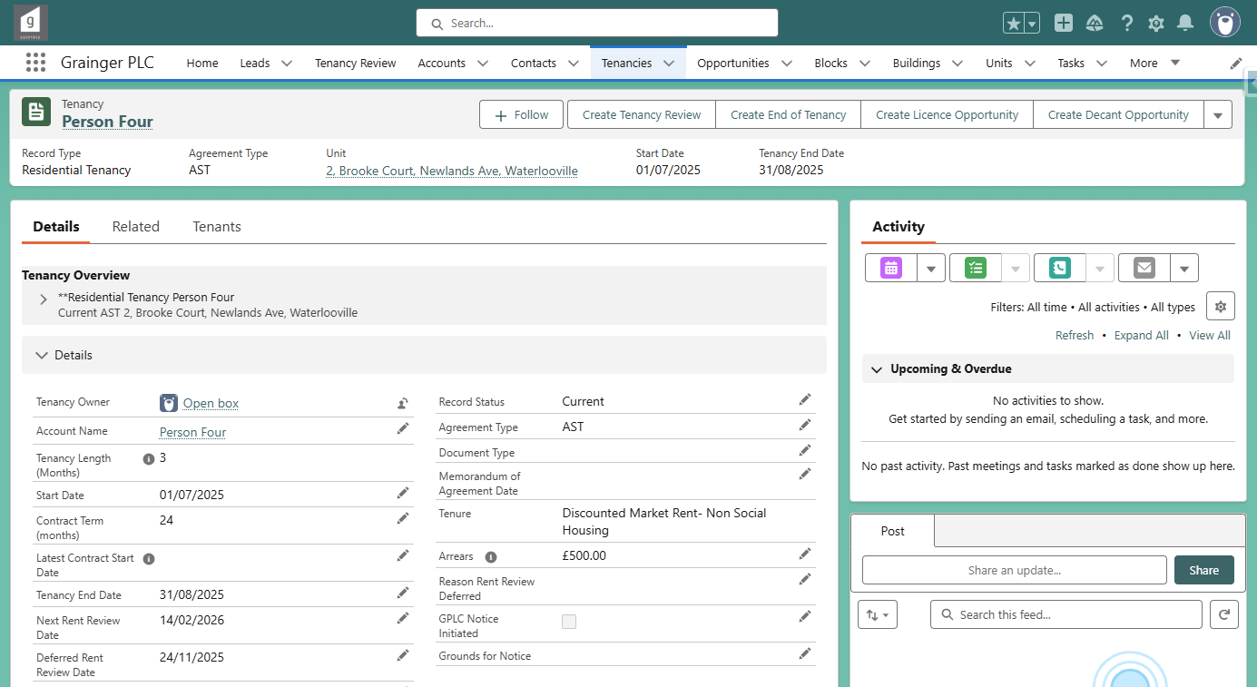

The next **Tenancy Review Date** is:

The *Deferred Rent Review Date* if any, otherwise

The *Next Rent Review Date* if any, otherwise

Theday after the *Tenancy End Date*.

* Update the default *Tenancy Review Date* if required, and select ‘Next’:

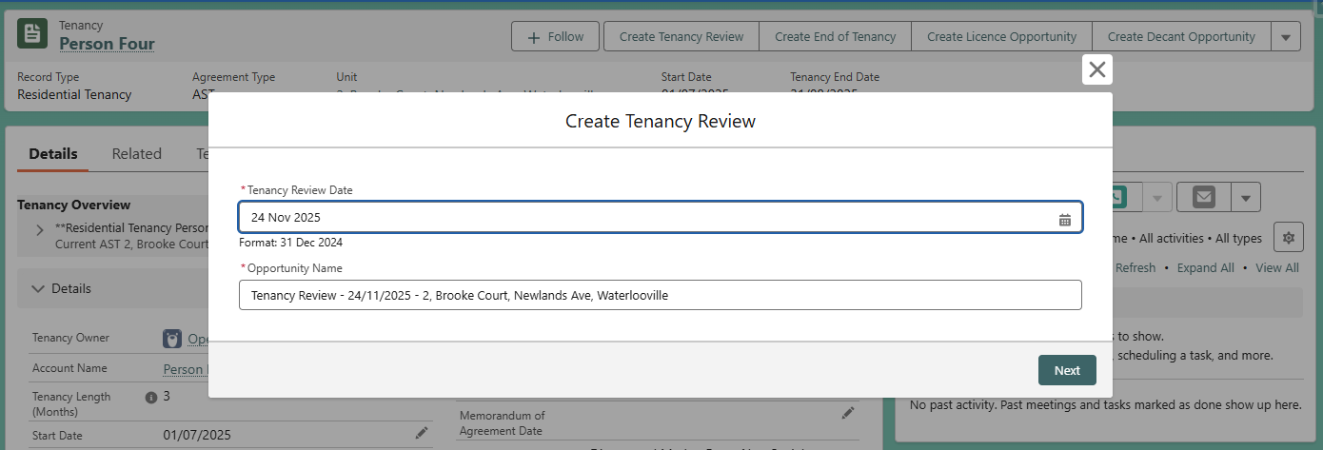

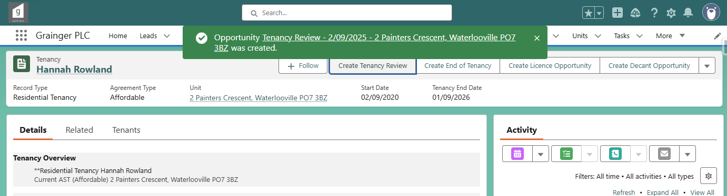

# Rent Approval

Asset Managers will set the target & minimum rent review price for each tenancy review opportunity in the **Rent Approval** screen.

* **Filters** - The Rent Approval list can be filtered by selecting the required filter options and clicking on ‘**Apply Filter’**.
  + Select ‘**Reset Filter’** to remove all selected filter options, select new options, and then click on ‘Apply Filter’ again.

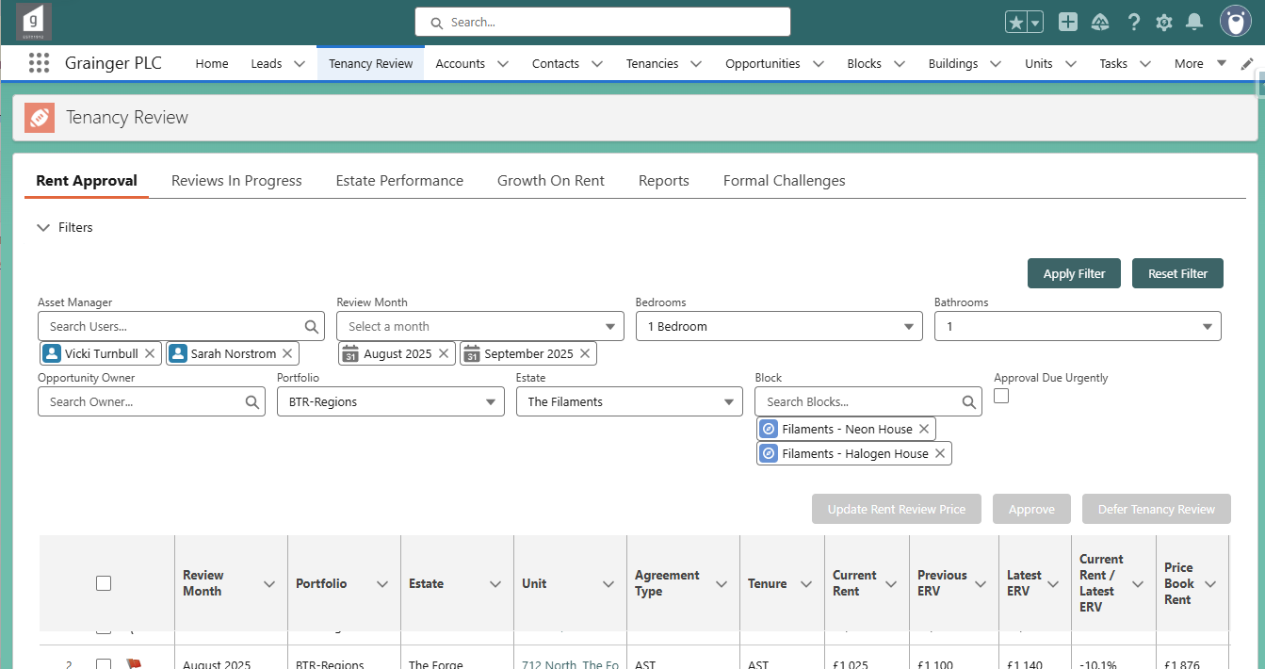

Click to hide & show the filter section.

Month in which the rent is due to increase.

Tick to only display tenancy reviews that need to be approved in the next week, or are already overdue.

* **Approval Due Urgently** - A red flag  in the first column indicates that rent approval is due today or is overdue. An amber flag  indicates that rent approval is due in the next week. Hover over the flag to see the exact due date.

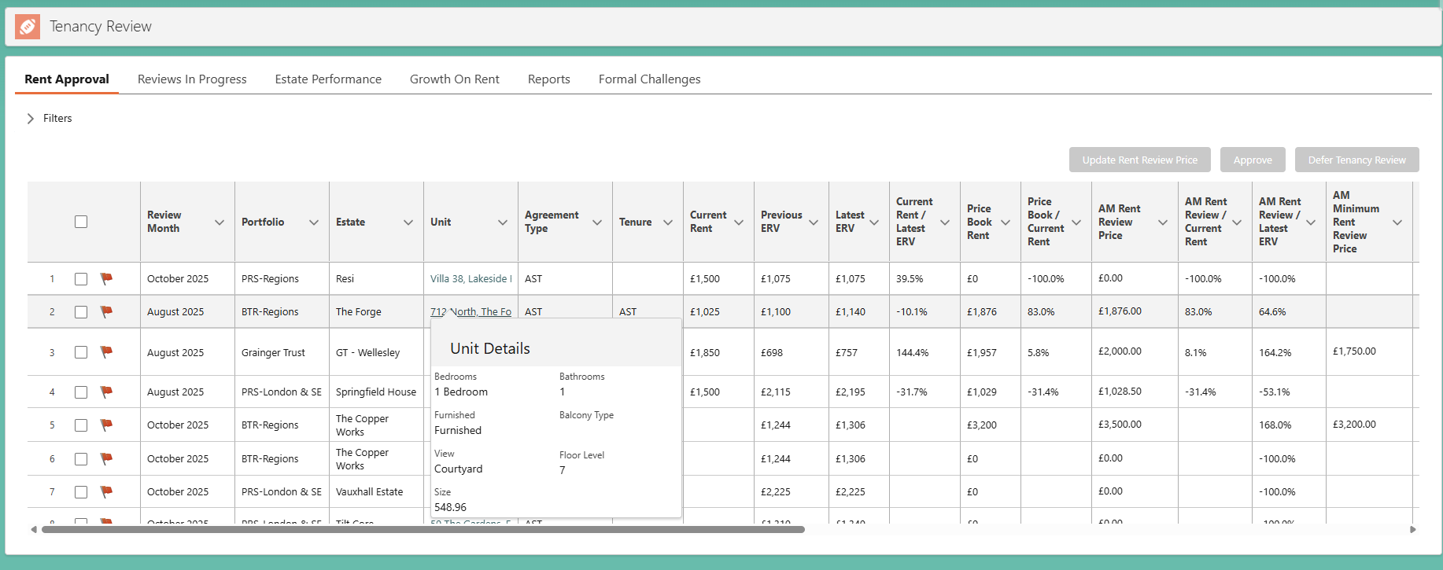

Hover over the unit to see additional unit information.

Hover over the latest or previous ERV values to see the applicable month & year:

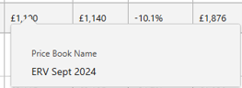

Hover over an urgent review flag to see the due date:

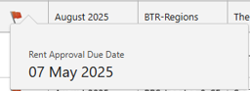

* Select the dashboard icon to open the Estate Performance Dashboard, pre-filtered by the corresponding estate, number of bedrooms & bathrooms, to see recent rent achieved on similar units.
* The following information can be updated in the Rent Approval list:
  + **AM Rent Review Price** – Target rent; required to be set for every tenancy review. This value will default to the **Price Book Rent**, but can be updated.
  + **AM Minimum Rent Review Price** – Required to be set for every tenancy review.
  + **AM Comments** – Optional
  + **Asset Manager** – Can be updated if an asset manager is on leave, for example.

Unsaved changes are highlighted.

Defaults to price book rent.

Arrears expressed as number of weeks of current rent.

* **Unsaved changes** are highlighted & are only saved when the user selects  at the bottom of the screen, or approves the tenancy review (see below).
  + Unlike approval, when the user selects ‘**Save**’ the tenancy review will remain in the *Rent Approval* screen and the saved changes may be updated at a later time.
* **Bulk Updates** – To update multiple tenancy reviews with the same value or comment:
  + Select some or all of the tenancy reviews listed using the checkboxes.
  + Update one of the values, tick the box to update the selected items, and ‘Apply’.
  + Save the changes.

Select / deselect all tenancy reviews in the list.

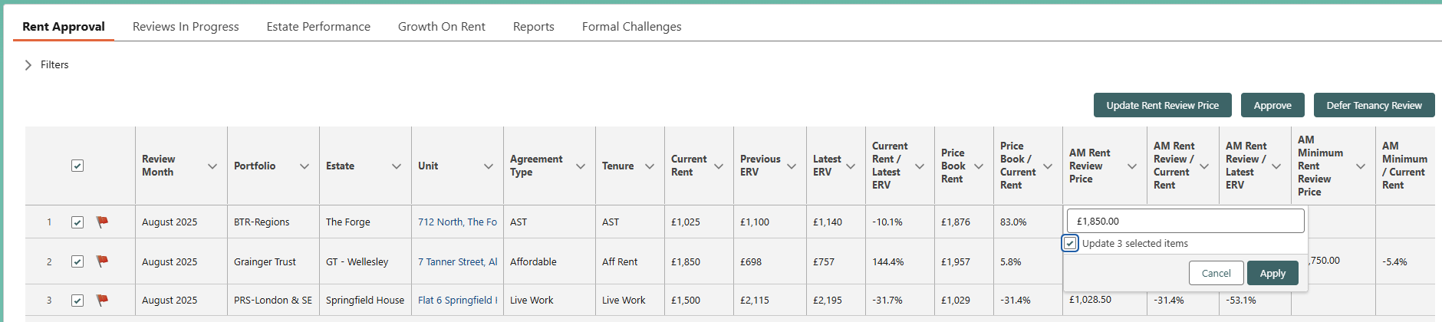

Select to apply a fixed % rent increase.

Tick to bulk update, then ‘Apply’ the update to all selected items.

* **Apply a Fixed % Rent Increase –** To calculate the *AM Rent Review Price* as a percentage increase on current rent:
  + Select one or more of the tenancy reviews using the checkboxes.
  + Select the ‘**Update Rent Review Price’** button.
  + Enter the % increase on current rent.
  + Select the values to update - *AM Rent Review Price*, or both *AM Rent Review Price & AM Minimum Rent Review Price.*
  + Select ‘Submit’.
  + Save the changes.

* **Approval** – Once the *AM Rent Review* and *AM Minimum Rent Review Prices* are finalised, the tenancy review can be approved.
  + These prices must both be populated in order to approve.
  + Select one or more of the tenancy reviews using the checkboxes, and then click the ‘**Approve’** button.
  + Once a tenancy review is approved, it will no longer appear in the Rent Approval screen. The rent review amounts are committed and ready to be communicated to tenants.

* **Defer Tenancy Review** – Asset Managers will be able to defer tenancy reviews to a later month where required.
  + Select one or more of the tenancy reviews using the checkboxes.
  + Click the ‘**Defer Tenancy Review’** button.

Enter the new rent review date that will be applied to all of the selected tenancies as well as the applicable reason(s), and ‘Submit’

* + Once deferred, any rent review prices or AM comments previously saved will be deleted. The tenancy review will be re-priced at the appropriate future time, based on the new rent review date, price book rent & ERVs at that time.

# Growth on Rent

Asset Managers can use the **Growth on Rent** screen to evaluate rent review prices during the rent approval process. These figures incorporate both approved and unapproved tenancy review prices.

Note that is screen is intended to provide a worst-case scenario growth figures for use during the pricing process. It does not reflect the growth on current rent or growth on ERV that is actually achieved.

Select a **portfolio** and **review** **month** to see a summary of the growth on current rent and growth on ERV based on the following:

* **AM Minimum Rent Review Price** – Original minimum as set by the asset manager on the Rent Approval screen.
* **AM Minimum Rent to Offer** – The original minimum unless there is counteroffer lower than the minimum that has been approved by the Asset Manager, in which case the lower counteroffer value is used.

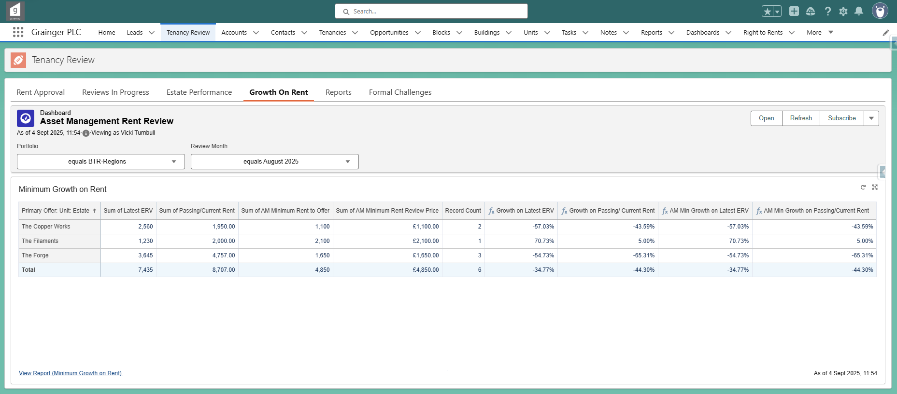

Number of tenancy reviews per estate

Growth relative to original minimum or approved counteroffer

Growth relative to original minimum

Lower of original minimum or approved counteroffer

Original minimum set by AM

* Select ‘**View Report’** to see more details.
  + Ensure that an *AM Minimum Rent Review Price* has been captured for all of the underlying tenancy reviews on the report. Missing minimums will result in incorrect growth percentages.

Red indicates AM Minimum Rent Review Prices still need to be captured for some of the tenancy reviews.

* + Toggle the ‘**Detailed Rows’** option on, to see the values for each underlying tenancy review:

# Estate Performance Dashboard

The **Estate Performance** screen provides information to support pricing decisions, such as recent rent achieved.

Filter the dashboard by estate and number of bedrooms & bathrooms as required.

* **Recent Rent Achieved on New Lets -** Lists the most recent new let opportunities that have been finalised (in ‘Audit’ or ‘Closed Won’) based on lease start date.
* **Recent Rent Achieved on Tenancy Reviews** -Lists the most recent tenancy review & renewal opportunities that have been finalised (in ‘Audit’ or ‘Closed Won’) based on the date of rent increase.
* **Available Units** – Shows the number of available live units by block and floor.

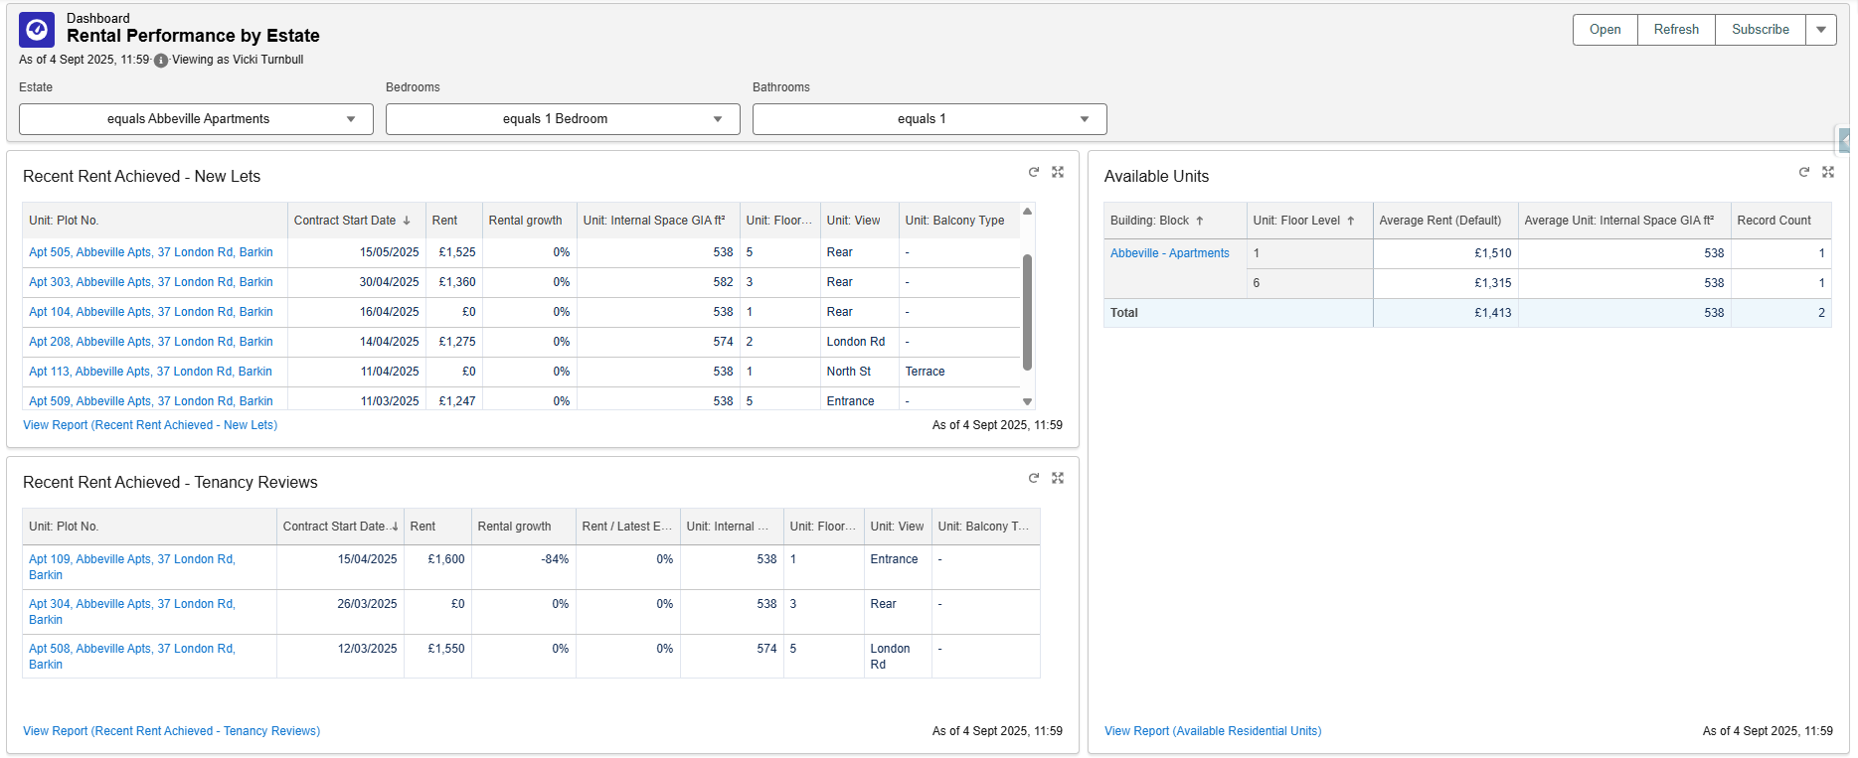

Number of available units

Click ‘View Report’ to see more information:

# Reviews in Progress

Negotiators can monitor tenancy review opportunities in the **Reviews In Progress** screen.

Tenancy review opportunities will only appear in this list once the rent review price has been approved by Asset Managers in the Rent Approval screen. Licences are the exception, they are not approved by Asset Management and will appear in the list immediately, once created.

* **Filters** -The list of tenancy reviews can be filtered by selecting the required filter options and clicking on ‘**Apply Filter’**.
  + Select ‘**Reset Filter’** to remove all selected filter options, select new options, and then click on ‘Apply Filter’ again.

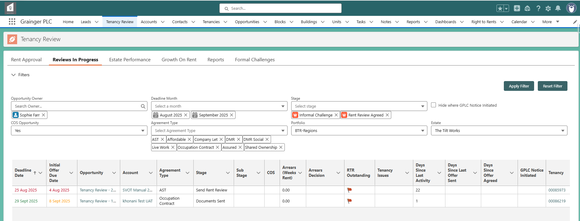

Filters by the deadline date for sending documents.

Click to hide & show the filter section.

* **Deadline Date** & **Deadline Month** refer to the date by which the applicable document (renewal contract, Section 13, RHW12, etc.) must be sent to the tenant; i.e. 9 weeks prior to the tenancy review date.

Click on column heading to sort.

Hover over for notes captured on the tenancy review.

‘Last Activity’ includes user updates or online responses from a tenant.

Flagged on the tenancy.

* **Deadline Date** is colour-coded:
  + Red = Deadline to send documents has been reached or overdue.
  + Amber = Documents are due in the next week.
  + Green = Documents have been sent.
* **Initial Offer Due Date** - The deadline for sending the 1st offer to the tenant; i.e. 9 weeks prior to the tenancy review date.
  + Red = Deadline has been reached or overdue.
  + Amber = Initial offer is due in the next week.
  + The date does not display at all once the initial offer has been sent.
* **Arrears (Weeks Rent)** – Displays any current arrears balance for the tenancy expressed as weeks’ worth of current rent. This value is colour-coded where there are outstanding arrears:
  + Red = No *Arrears Decision* has been captured on the tenancy review.
  + Amber = Where *Arrears Decision* is ‘Awaiting Credit Control Feedback’.
  + Green = Once any other *Arrears Decision* has been captured.
* **RTR Outstanding** – The overall Right-to-Rent status for the opportunity where the agreement type requires RTR information to be captured. See also Right-to-Rent Information.
  +  - A new RTR is required from one or more tenants.
  +  - One or more tenants have a RTR in ‘RTR Not Required’ status.
  +  - All tenants have a RTR that is valid as at the tenancy review date.

Tenancy review opportunities will no longer appear on this screen once they progress to ‘Audit’ or when in ‘Formal Challenge’ stage. See the report of current Formal Challenges.

# Tenancy Review Opportunity Details

A tenancy review opportunity will progress through a series of stages:

|  |  |
| --- | --- |
| **Tenancy Review Opportunity Stages** | |
| **Rent Review Approval** | Asset Management has not yet approved the new rent. |
| **Send Rent Review** | New rent has been approved.  Negotiators can review the opportunity & send the offer. |
| **Rent Review Sent**  *Sub stages:*   * *Not Viewed* * *Viewed* | Offer has been sent; no response has yet been received from the tenant.  Sub stage updates automatically to ‘Viewed’ where a tenant views the offer online but doesn’t respond. |
| **Informal Challenge**  *Sub stages:*   * *Pending AM Approval* * *AM Approved* * *AM Rejected* | Tenant has made a counteroffer or asked a question. Stage updates automatically where the tenant responds online.  Opportunity remains in this stage until the new offer is sent.  Sub stages update automatically where a counteroffer below the AM minimum progresses through the asset manager approval process. |
| **Rent Review Agreed** | Tenant has accepted the offer.  Stage updates automatically where the tenant responds online. |
| **COS**  *Sub stages:*   * *Application form sent* * *With PM for approval* * *In referencing* * *Referencing complete* * *Right to Rent in progress* * *COS fail* | Tenant has requested a change or sharer & awaiting related approval, documents, or referencing.  Sub stages must updated manually. |
| **Documents Sent**  *Sub stages:*   * *All signatures outstanding* * *Landlord signature outstanding* * *All Signed both parties* | Documents have been sent.  Waiting for signature where necessary, or waiting for period to see if tenant responds to Section 13 or RHW12. |
| **Formal Challenge** | Tenant has initiated legal proceedings to dispute the rent. |
| **Audit** | Tenancy review is finalised.  Qube & direct debits can be updated with the new rent. |
| **Closed** | Closed Won / Closed Lost |

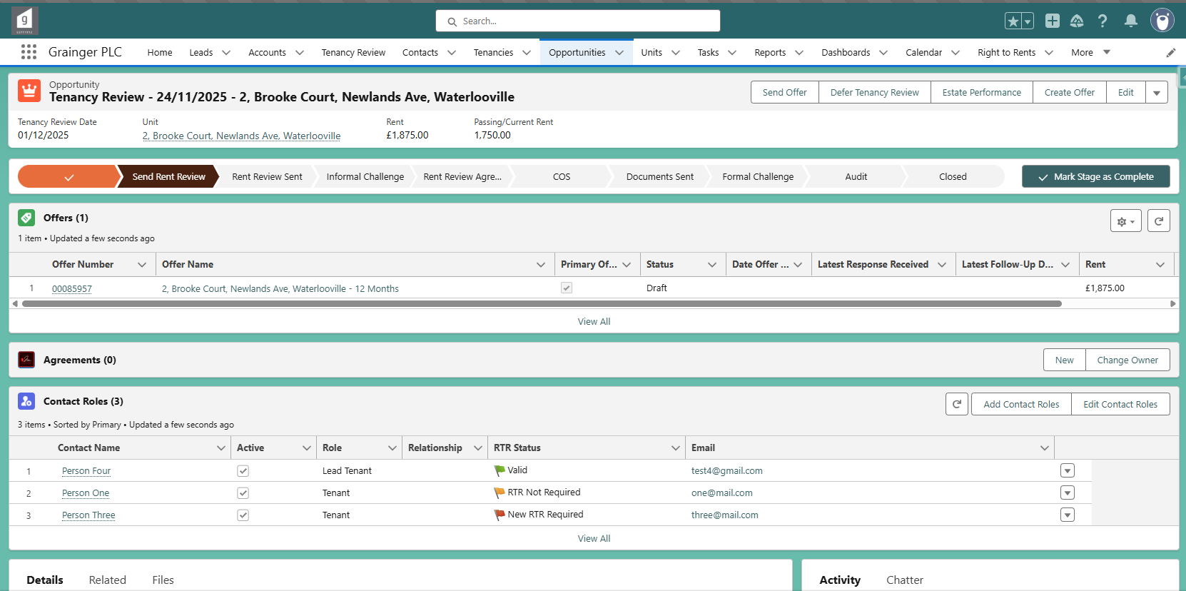

Tenancy review date = date of rent increase

See the RTR status for each tenant, relative to the tenancy review date.

Select the ‘**Estate Performance’** button on the opportunity screen to open the Estate Performance Dashboard and see recent rent achieved on similar units. When opened via this button, the dashboard will be pre-filtered by the same estate, number of bedrooms & bathrooms as the opportunity.

The opportunity’s *Details* tab contains a lot of information, however much of this is prepopulated.

* **Opportunity Details** – are mostly set when the opportunity is created; the information highlighted below can be updated where necessary.
  + *Tenancy Review Date* & *Review Month* will update when a tenancy review is deferred.

* **Current Tenancy Information** – is sourced from the tenancy.
  + *Passing/Current Rent* can be edited if incorrect.
  + All other information will update immediately if changed on the tenancy.

* **Review Pricing** - Contains the rent review prices approved by the Asset Manager and a snapshot of ERVs & Price Book Rent at the time of approval. This should not need to be updated.

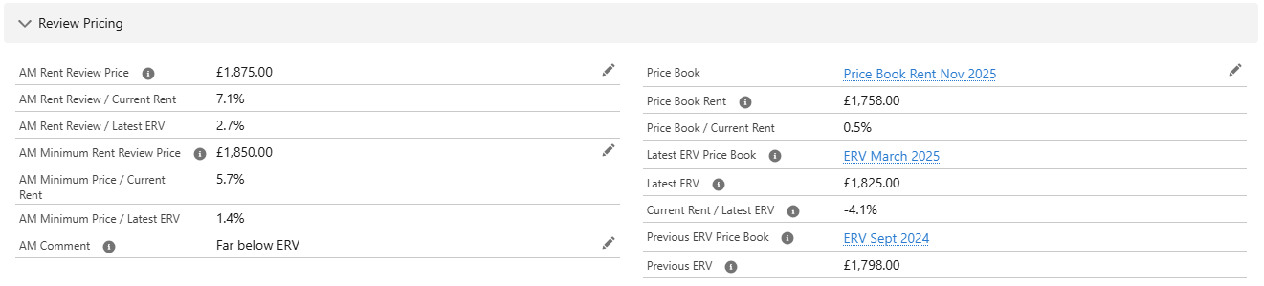

* **Review Factors** – must be reviewed and updated where applicable.
  + **Arrears** – The current arrears balance for the tenancy is updated daily and is also calculated as weeks’ worth of current rent. Where there are arrears:
    - Use the *Arrears Decision* to record where ‘Awaiting Credit Control Feedback’ and then to record the final decision.
    - Capture additional *Comments* as required*.*
  + **COS Opportunity** – Tick where the tenant has requested a change of sharer.
  + **Tenancy Issues** – Flag where there are issues that may impact the tenancy review. Where checked, additional notes may be captured.
  + **RTR Outstanding** – The overall Right-to-Rent status for the opportunity where the agreement type requires RTR information to be captured.
    - See Right-to-Rent Information.

* **Primary Offer Information** – will update automatically from the primary offer.
  + *Contract Start Date* will update when a tenancy review is deferred.

Text displayed when tenants view the offer.

* **Milestones** – Displays the target milestone dates (due dates) as well as the actual date on which the milestone was achieved. These should automatically update as the opportunity progresses.

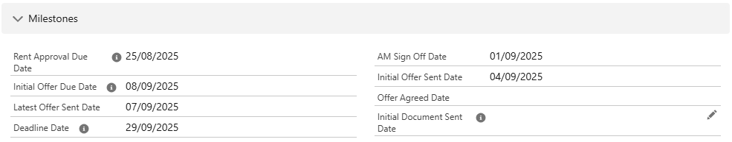

* **Unit Information** – Sourced from the unit as well as the current block pricing notes; cannot be directly updated.

* **Opportunity Closed Lost Reason** – as captured when the opportunity is Closed Lost. Note that if an **End of Tenancy** is created for tenancy that has a tenancy review opportunity in progress:
  + The opportunity will be automatically updated to ‘Closed Lost’, with *Lost Reason* of ‘Tenant Gave Notice.
  + A task will be assigned to the negotiator to notify them that the tenant gave notice and prompting them to capture renewal feedback.
  + The End of Tenancy will be linked to the opportunity.

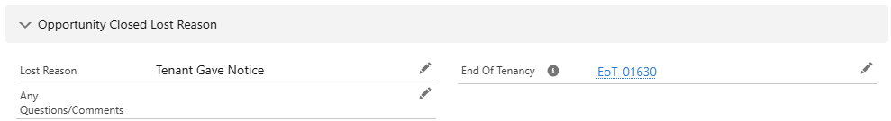

## Right-to-Rent Information

RTR information can be viewed in several places. These flags are only displayed where the opportunity requires RTR information to be captured.

* **RTR Outstanding** – a summary of the overall RTR status for the opportunity can be viewed in the Reviews in Progress list and in the opportunity’s *Review Factors*.
  +  - A new RTR is required from one or more tenants.
  +  - One or more tenants have a RTR in ‘RTR Not Required’ status.
  +  - All tenants have a RTR that is valid as at the tenancy review date.

* **RTR Status** – is displayed for each tenant; calculated relative to the *Tenancy Review Date*.

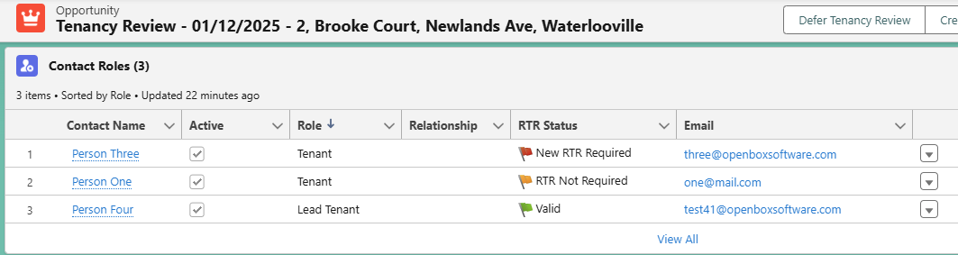

* **Right to Rents** – Displays all RTR records for the tenants that are completed or in progress. Use this list to view or update individual RTR records.
  + Note that the flag in this list does not consider the *Tenancy Review Date*. Therefore a RTR may be ‘Completed’ and display as green or amber in this list; however if the *Date Next RTR Required* is before the *Tenancy Review Date*, then the tenant will appear with a status of ‘New RTR Required’ in the *Contact Roles* list (above) and the opportunity cannot be completed until a new RTR is obtained.

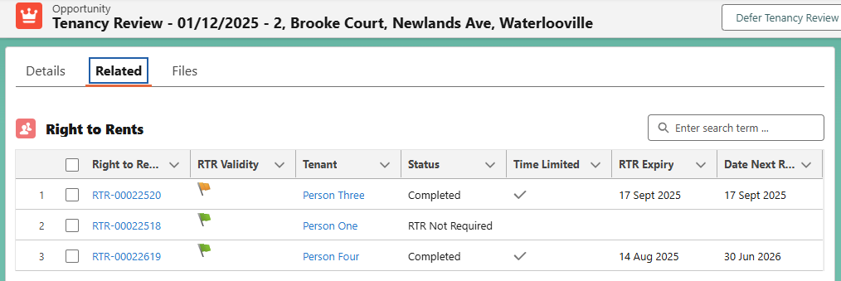

## Set Licence Prices

Tenancy reviews for **parking and shed licenses** are not priced by Asset Management. For these opportunities, the new rent must be set by either of the following methods:

* If price book rent has been saved in Salesforce for the unit:
  + Select the ‘**Update Rent’** button on the opportunity.
  + The price book rent for the tenancy review month will be saved on the opportunity and the offer.

* Manually capture the rent on the **offer**:
  + Select the ‘Edit Product’s button on the offer’s *Related* tab.

* + Enter the new rent as the ‘Rent (Offered)’ & save:

## Offer Details

The offer will progress through a series of **statuses**:

* The offer status will update automatically when offers are sent through Salesforce, the tenant responds online, and when counteroffers are managed & approved in Salesforce.

An **initial offer** is automatically created when the tenancy review is generated.

* Offer information such as term, payment periodicity, break clause and special clause defaults to the current tenancy details.
* Rent is set when the Asset Manager approves the *AM Rent Review Price*.

Review the default offer information and update if necessary.

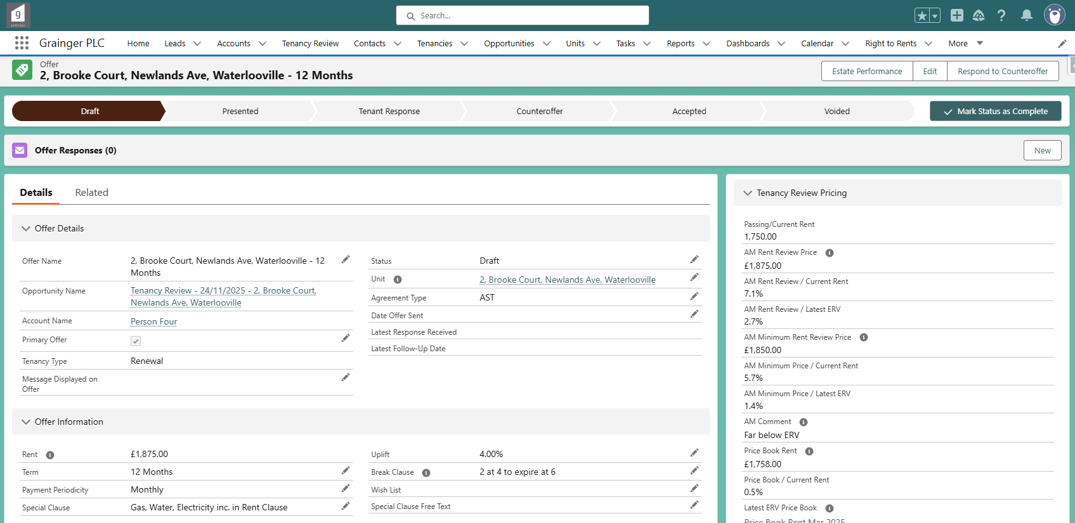

Review & update

Opens the Estate Performance Dashboard, pre-filtered by estate, number of bedrooms & bathrooms.

Offer details section should not need to be manually updated

Pricing information as seen by the Asset Manger when approving the new rent.

Where the offer is flagged as the ‘**Primary Offer’**, updating the offer information will automatically update the ‘Primary Offer Information’ on the opportunity.

For a **periodic tenancies**, or where a tenancy is changing to periodic: Select ‘N/A’ for the *Term* and *Break Clause*:

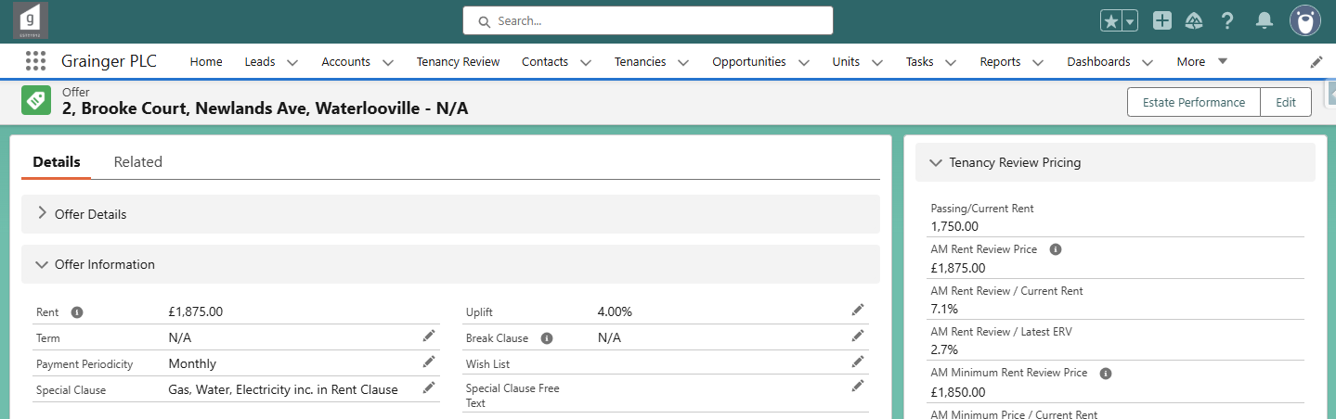

It should generally not be necessary to **manually create a new offer** on a tenancy review opportunity, however if required:

* Select the ‘Create Offer’ button on the opportunity.
* Refresh the *Offers* related list to see the new offer.
* Update the previous primary offer: Untick the ‘Primary Offer’ box.
* Update the new offer as required and tick the ‘Primary Offer’ box.

# Send an Offer

Once the offer details have been reviewed, the primary offer can be sent to the tenants.

* Select the ‘**Send Offer**’ button on the opportunity screen.

* Check the details. All tenants are listed and will receive notification of the tenancy review.
* Optional: Enter a message that will display to the tenants on the offer.

* Optional: Drop / upload files that will be attached to the email sent to the tenants.
  + Note that **multiples files** may be uploaded, however they all need to be selected at the same time.
* Select ‘Send’.
* Once sent, the files and the message (if any) will be saved on the offer.

On sending an offer: The offer status updates to ‘Presented’ and the offer name updates to reflect the date sent.

On sending an offer: The opportunity stage updates to ‘Rent Review Sent’.

## Reminder SMS & Emails

An **SMS** (text message) reminding tenants to respond to the offer is sent the following afternoon, provided that none of the tenants have yet responded (i.e. the opportunity remains in the *Rent Review Sent* stage).

* An SMS is only sent where the tenant is person (not a company) with a valid UK mobile phone number, regardless of the *Suppress Automated Renewal Chase Emails* flag*.*

**Chaser emails** reminding tenants to respond to the offer will be sent after 3, 7 & 10 days until a response is received from any of the tenants (and the opportunity moves out of the *‘*Rent Review Sent’ stage).

* Only fixed term offers that are sent via the above process are sent chaser emails.
* Chaser emails are not sent for parking or shed licences, regardless of whether they are fixed term or periodic.
* Chaser emails are not sent where the opportunity is flagged to *Suppress Automated Renewal Chase Emails.*

Offer emails, chaser emails & any tenant replies to these emails can be viewed in the opportunity’s activity timeline.

Record of whether the SMS (text message) was successfully sent or not.

# Offer Responses

When a tenant views or responds to an offer online, a record of each the **offer response** can be seen on the offer.

* Each tenant is able to respond separately to an offer; each individuals response can be seen. Where multiple offers are sent over time, tenants can respond again to each new offer.

The tenancy review negotiator will be able to monitor responses in the Reviews in Progress list:

* Where the tenant views the offer online but does not respond, the opportunity sub stage updates to ‘**Viewed’**.
* Where the tenant responds online, the opportunity stage will update to ‘**Rent Review Agreed’** or ‘**Informal Challenge’** as applicable.

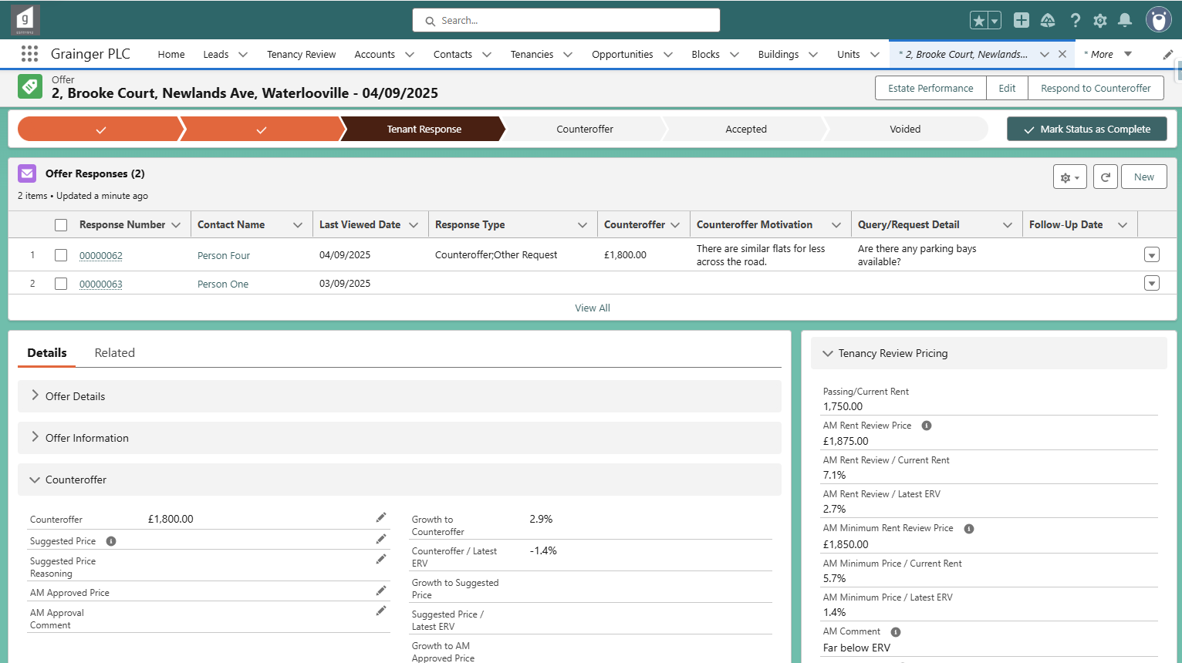

Offer stage updates when tenant responds

Click to see / add details.

Date the tenant last viewed the offer online, even if they did not respond.

A record of any conversations with the tenant can be saved on the offer response, if required:

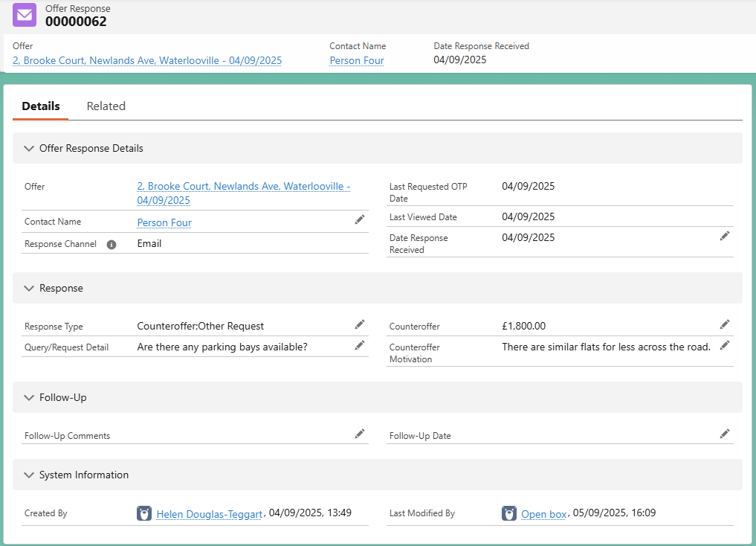

Click on the response number to open the offer response details.

Enter follow-up comments and date.

A full history of each time the tenant **viewed the offer details online** can be found on the offer response’s ‘Related’ tab.

If a tenant responds via another channel, for example if the negotiator has a phone call with the tenant, the **response can be manually captured**:

* Select the ‘New’ button:

* Select the tenant (contact name) and capture the response details.
  + Note that additional response options that are not available to the tenants online (i.e. *Requested to Terminate* and *Change of Sharer*) can be captured where necessary.

Remember to incorporate information provided in the tenant responses when capturing the renewal feedback.

# Responding to Counteroffers & Asset Manager Approval

Where a tenant has made a counteroffer, the negotiator will enter their suggested price.

* On the offer screen, select ‘**Respond to Counteroffer**’.

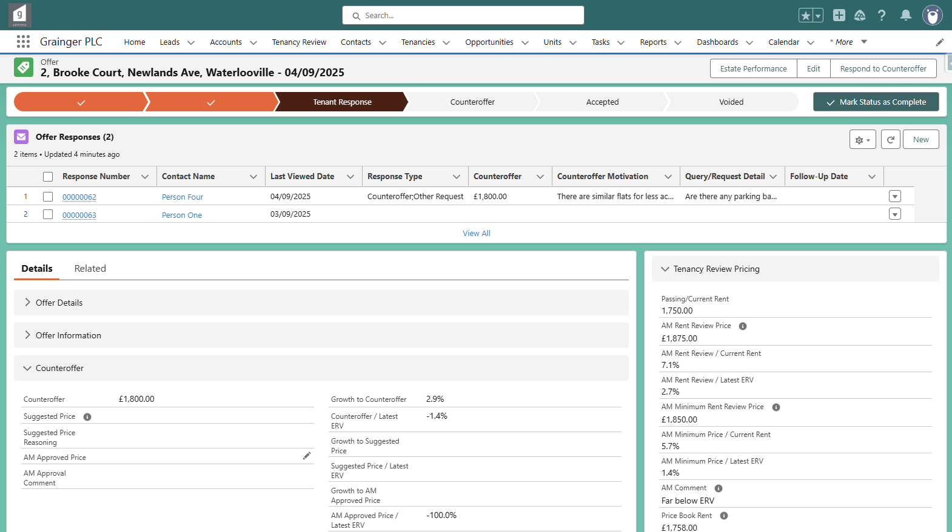

Counteroffer section now displays.

* Enter the suggested price (if different to the counteroffer) and enter reasoning.

## Suggested Price Above AM Minimum

If the suggested price is **not below** the *AM Minimum Rent Review Price*:

* A new offer is automatically created with the suggested price set as the rent.
* The negotiator can send the new offer to the tenants immediately by selecting ‘**Create & Send Offer**’ & ‘Next’.
  + This will open the same screen as per Send an Offer, where the user can enter a message and upload attachments to the offer email if required.
* Otherwise, select ‘**Create Offer**’ & ‘Next’.
  + The new offer that is created can be sent at a later time; see Send an Offer.

The new offer created is now the primary offer & has the same offer information (such as term and payment periodicity) as the previous offer.

New primary offer created with suggested rent.

## Suggested Price Below AM Minimum

If the suggested price is **below** the *AM Minimum Rent Review Price*, the user will be asked to confirm that the suggested price will be sent to the Asset Manager for approval.

* An approval request is sent to the Asset Manager, and can be viewed on the offer’s *Related* tab:

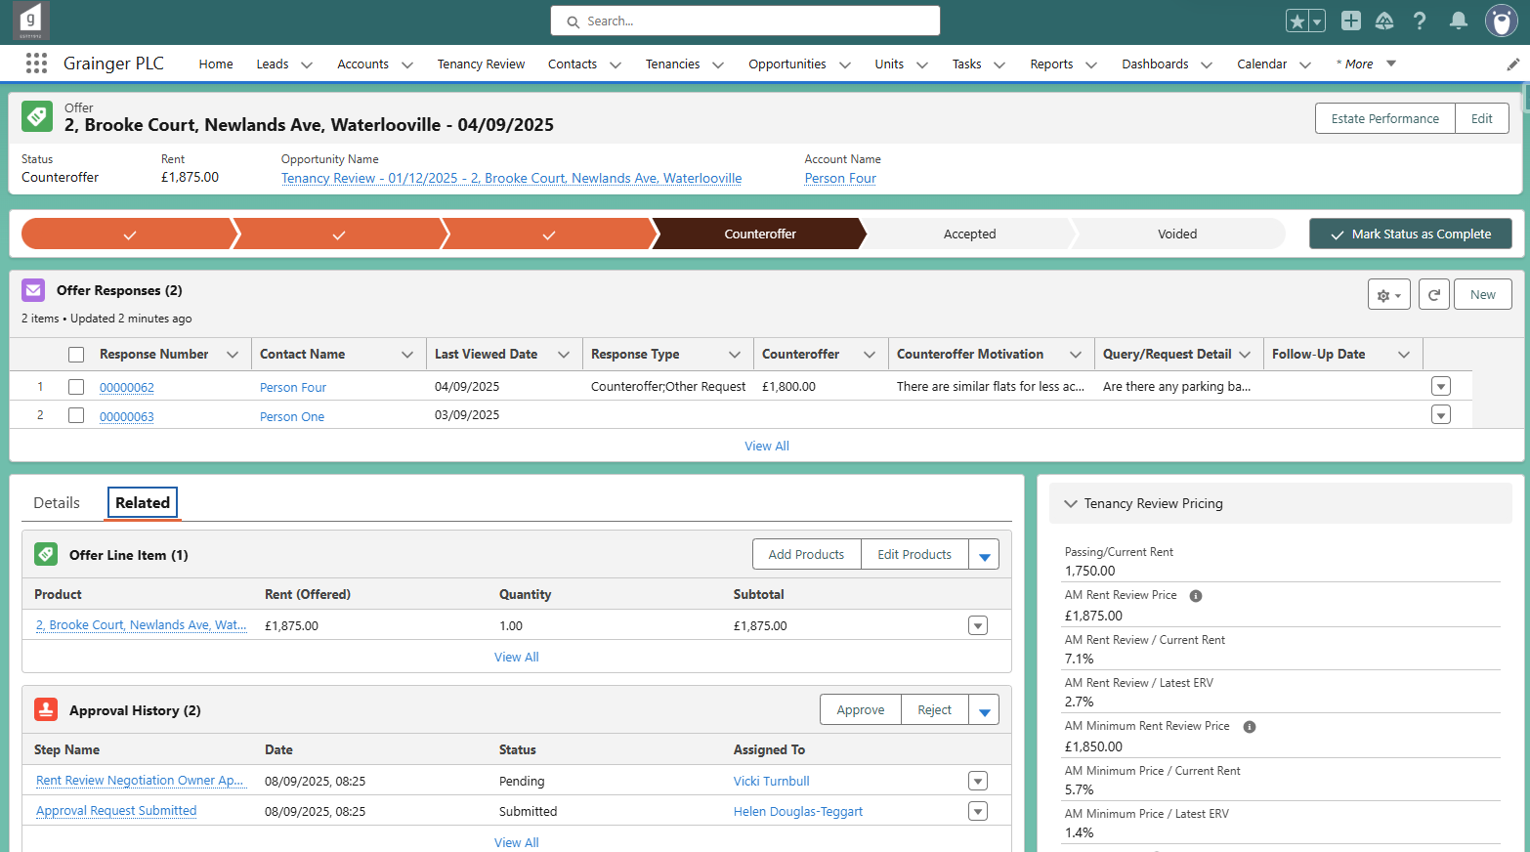

History of the approval request sent to the Asset Manager.

Click to open the approval request.

Status updates

## Asset Manager Approval

Asset Managers will be able to see offers pending their approval on their home page and as a notification.

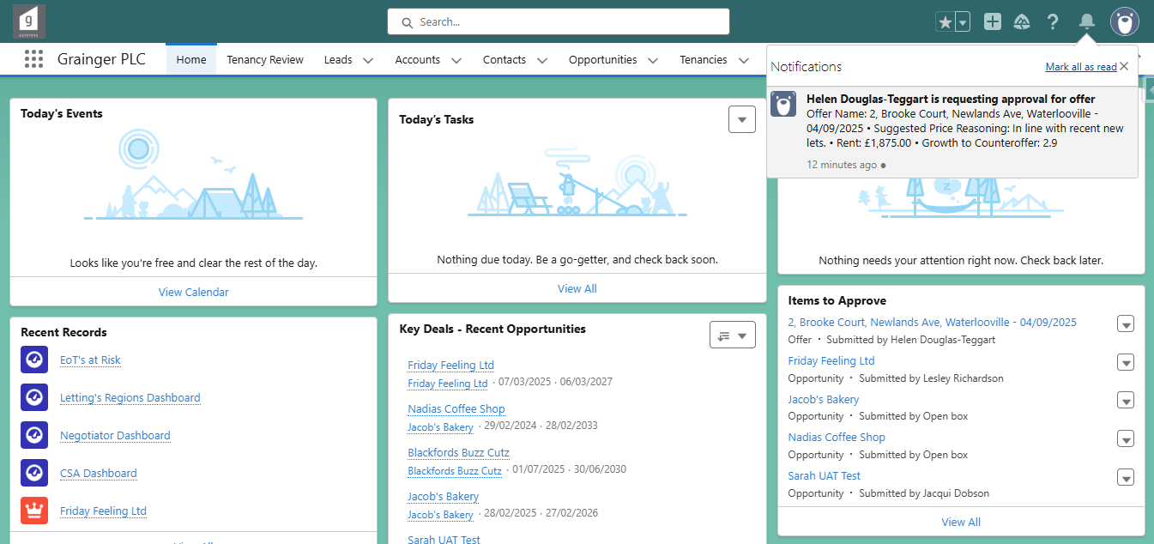

Approval requests

Open the approval request to see a summary of details, including:

* **Rent** – Rent offered to the tenant.
* **AM Minimum Rent Review Price** – as originally set by the Asset Manager.
* **Counteroffer** – by the tenant. Growth from current rent to the counteroffer as well as counteroffer price relative to the latest ERV is displayed.
* **Suggested Price** – by the Tenancy Review Negotiator, if they do not agree with the counteroffer. Growth from current rent to the suggested price as well as suggested price relative to the latest ERV is displayed.
* **Suggested Price Reasoning** – Negotiator’s motivation for the suggested price (or to got with the counteroffer if there is no suggested price).

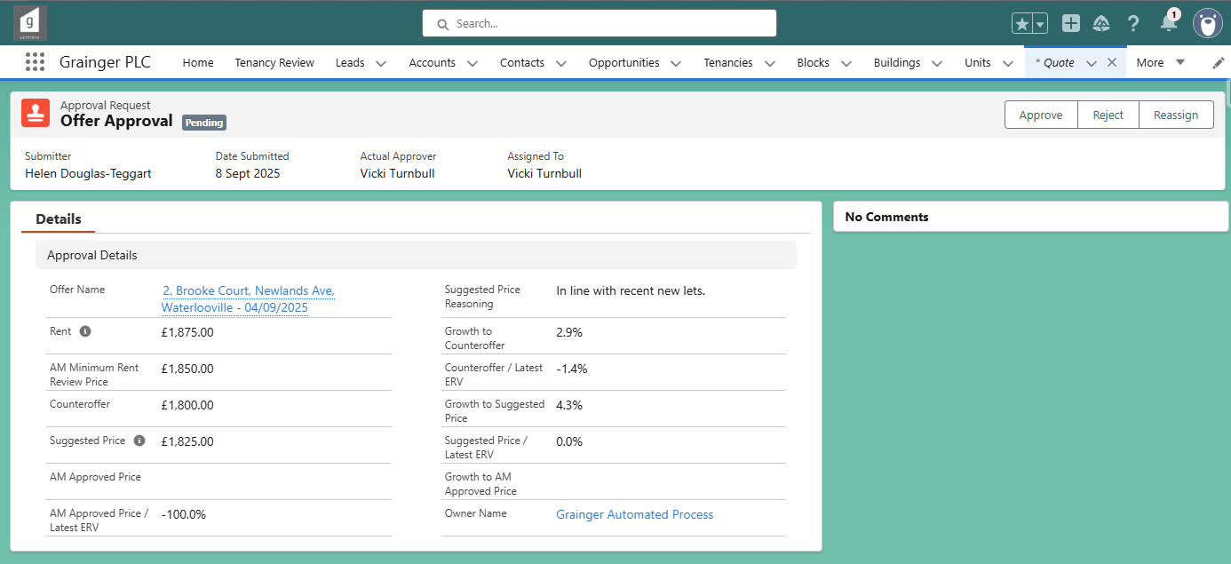

Open the offer to see more details, or optionally enter an alternate price.

The approval request can be reassigned to another AM if required.

The Asset Manager has 3 options:

* **Reject** – The tenant will not be offered any further rent reductions.
  + Select the ‘**Reject’** button the approval request screen (above).
  + The AM will be prompted to enter a comment, which is required when rejecting.
  + The opportunity sub stage is updated to ‘AM Rejected’, which the tenancy review negotiator will be able to monitor in the Reviews in Progress list.
* **Approve the suggested price** (or the counteroffer if there is no suggested price)
  + Select the ‘**Approve’** button the approval request screen.
  + The AM will be prompted to enter a comment, which is optional when approving.
* **Approve an alternate price** 
  + Open the offer details by clicking on the offer name.
  + On the offer screen (below), enter an alternate amount as the ‘**AM Approved Price**’.
  + Then ‘**Approve’** the approval request.

Pricing information as seen by the Asset Manger when originally approving the rent review price.

See the tenant’s motivation for the counteroffer.

Optional: AM may enter an alternate price.

Review growth to the alternate AM Approved Price.

* + Navigate back to the approval request from the **Approval History** on the offer’s ‘Related’ tab in order to approve; or simply click on the ‘Approve’ button here:

Navigate back to the approval request.

Approve or reject the approval request.

When the Asset Manager **approves** either the suggested price or an alternate price:

* A new (primary) offer is created with the approved price set as the rent.
* The opportunity sub stage is updated to ‘AM Approved’, which the tenancy review negotiator will be able to monitor in the Reviews in Progress list.
* The negotiator can send the new offer to the tenant; see Send an Offer.

# Renewal Feedback

Capture any positive or negative feedback from the tenants:

From opportunity’s related list:

Select ‘New’ feedback and then select ‘Renewal Feedback’.

Capture all positive feedback or all reasons for not continuing the tenancy, as applicable.

Capture the renewal outcome.

# Sending Documents

Once the tenant has agreed to the rent increase (or if not required to agree – has not made an informal challenge), then the contact & document can be generated:

* Select ‘Create Contract’.

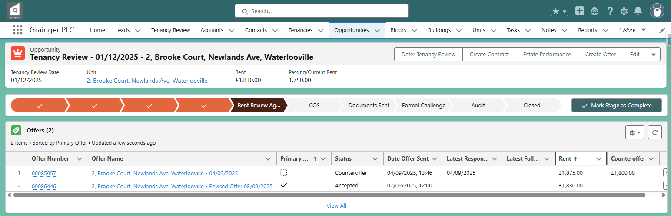

* Select the applicable document type:

* Open the newly created contract from the opportunity’s *Related* tab:

* Select ‘Generate Documents’:

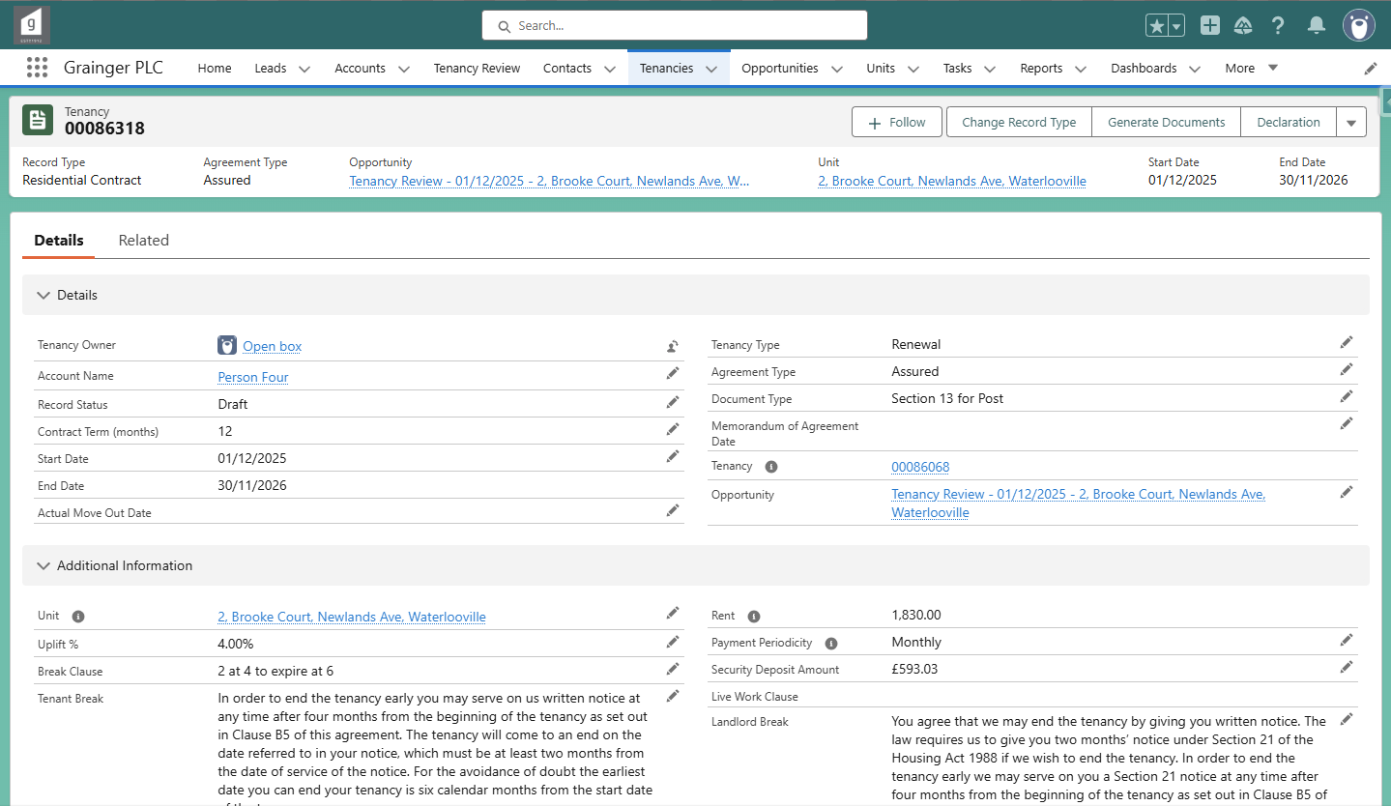

The security deposit amount is sourced from the tenancy information.

## Section 13 for Post

**Section 13 for Post** documents for *Assured* agreement types are generated through Salesforce. The document includes a cover letter and the Form 4.

Note that the following information on the form is sourced from the **tenancy**; this information should be checked and updated, if necessary, before generating the document:

* First rent increase date after 11th February 2003
* Current rent
* Current payment periodicity

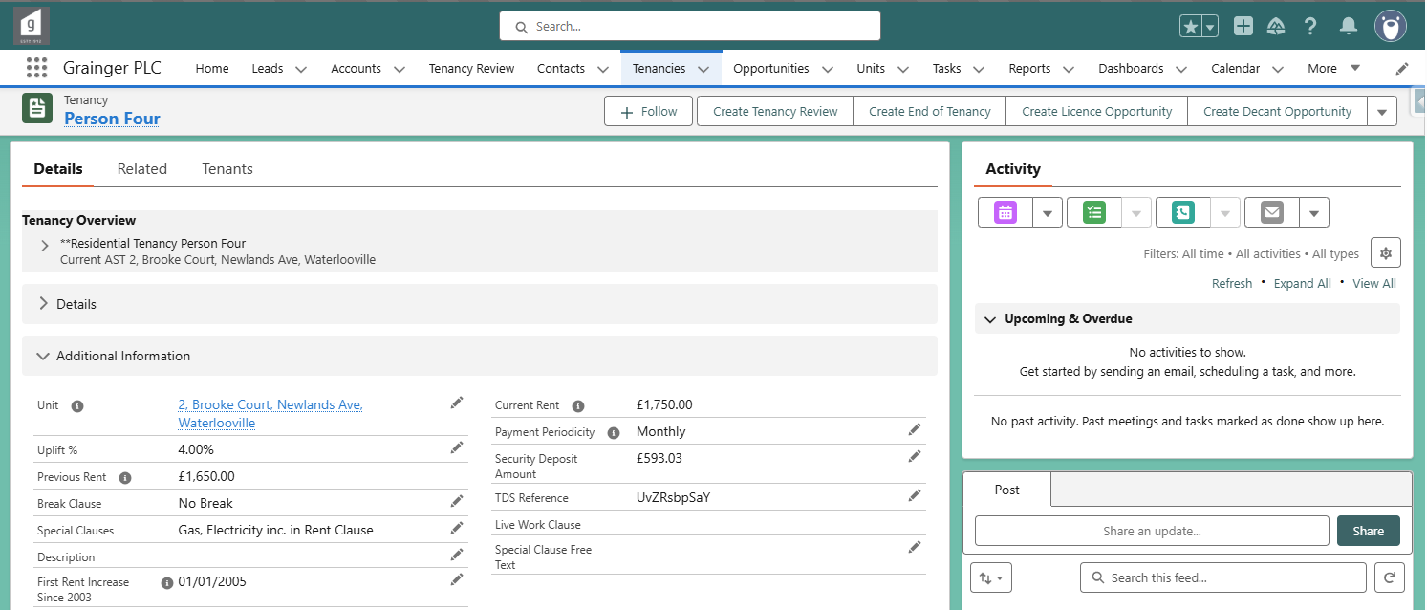

Once generated, the document can be opened, printed and posted:

## RHW12

**RHW12** (Notice of Variation of Rent) forms for Welsh occupation contracts are generated through Salesforce.

This document does not need to be signed by tenants.

* The user will be assigned as the sole **signer**, to sign on behalf of the landlord via Adobe Sign.
* The tenant(s) and any guarantor will be assigned as **certified recipients**.
  + Once the document is signed, they will receive an email via Adobe Sign from which they can access the signed document.

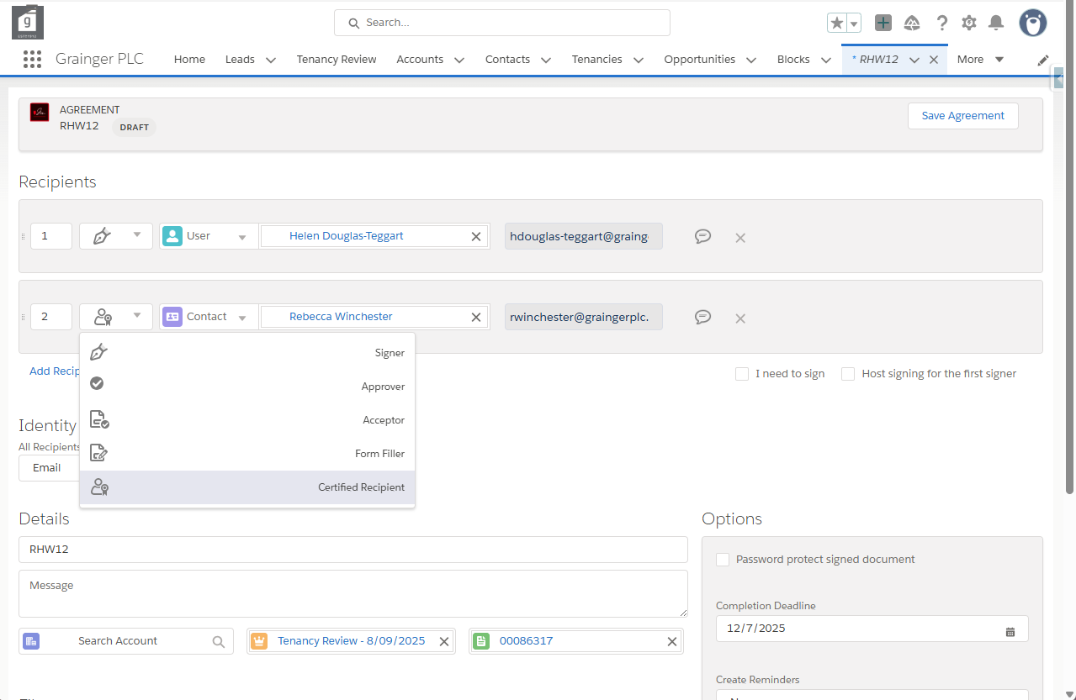

# Defer Tenancy Review

A tenancy review can be deferred to a later date in several ways -

**Before** the tenancy review opportunity is created:

* Capture the D*eferred Rent Review Date* and *Reason Rent Review Deferred* on the **tenancy**:

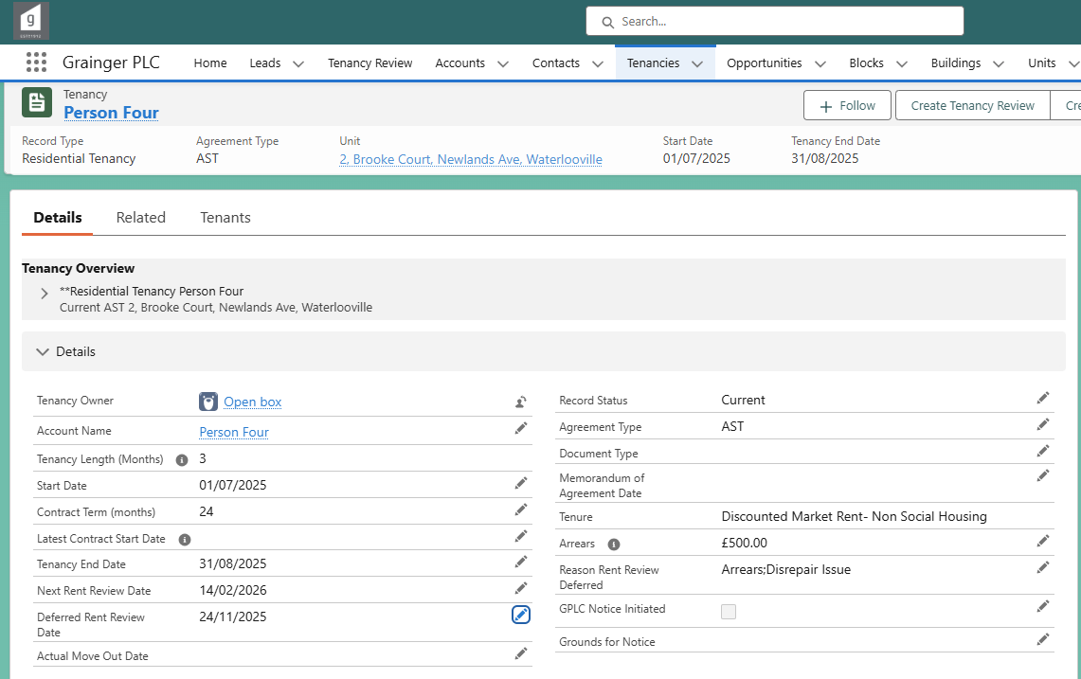

**After** the tenancy review opportunity has already been created:

* Asset Managers can defer one or more tenancy reviews from the Rent Approval screen.
* Tenancy Review Negotiators can defer an individual tenancy review opportunity.
  + When viewing the opportunity: Select the ‘**Defer Tenancy Review’** button.

* + Enter the *Deferred Rent Review Date*, reason(s) and ‘Submit’:

* + No further updates are required. The tenancy is automatically updated with the *Deferred Rent Review Date* & reason. The opportunity is automatically pushed out to the new date; all previous pricing is deleted.

# Block Pricing Notes

**Pricing notes** may be captured for an entire block.

This can be used to capture information that applies to all units in the block and that may affect pricing or require tenancy reviews to be deferred. Try to add dates for time-limited factors.

Pricing notes will be displayed to asset managers in the Rent Approval screen and to negotiators in the tenancy review opportunity details for any tenancy review in that block.

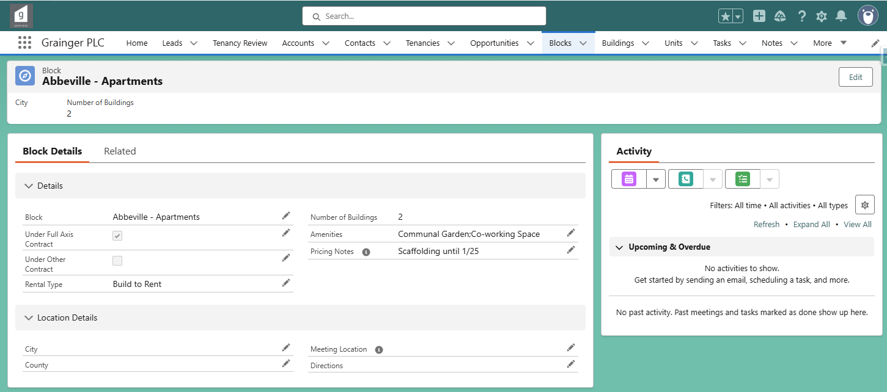

# Reports

## Tenancy Review Dashboard

The **Reports** screen provides the following exception reports:

* **Tenancy Review Due in 3 Months & No Opportunity in Progress**
  + Most current tenancies that are due for rent review within the next 3-months should have a renewal or tenancy review opportunity in progress. Those that do not will appear in this report.
  + Ensure that all the exceptions in this list are valid, for example where the tenant has confirmed they will be moving out.
* **Tenancy Review Overdue or No Review Date & No Opportunity in Progress** 
  + This reports lists any current tenancies that:
    - Have **no tenancy review date** (i.e. no *Tenancy End Date*, *Next Rent Review Date*, or *Deferred Rent Review Date* is saved on the tenancy), or
    - Have a **tenancy review date in the past** and there is no renewal or tenancy review opportunity in progress.
  + There should be no exceptions listed in this report.

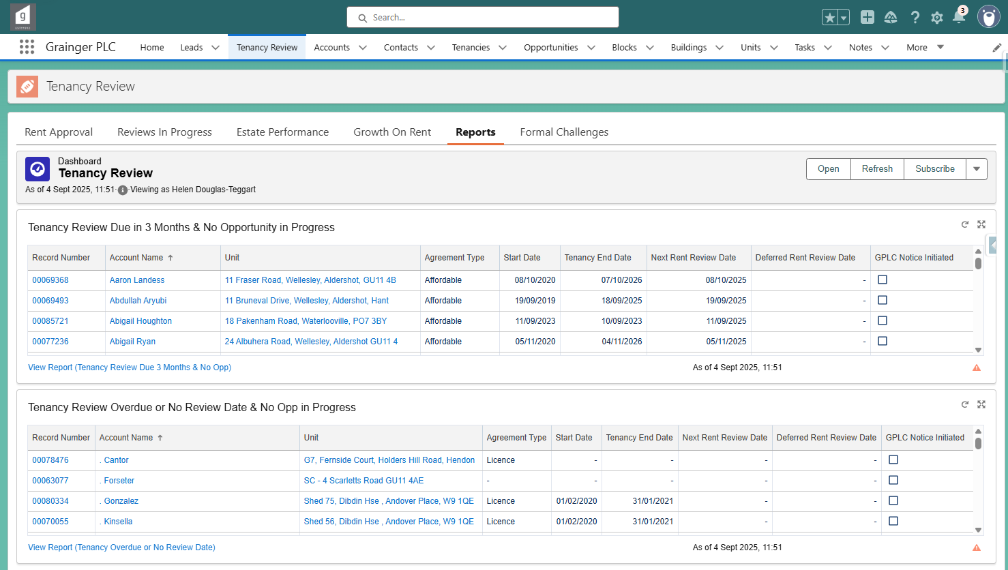

Note that both of these reports exclude decants, occupation licences, and tenancies where the tenants have already moved out.

## Formal Challenges

All tenancy review opportunities that are currently in a ‘Formal Challenge’ status can be viewed on the **Formal Challenges** screen.

Note there is currently no system-based process to manage formal challenges.